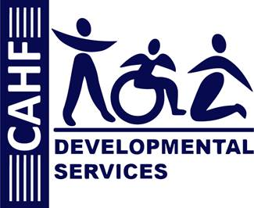

**Life Safety Code (LSC): RATING the Resident on the Risk Factor**

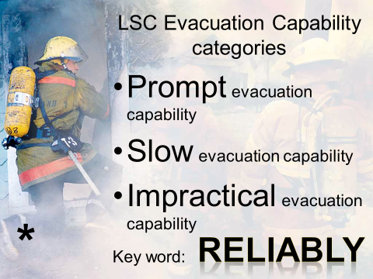

**RISK OF RESISTANCE**

1. Minimal Risk;
2. Risk of Mild Resistance; or
3. Risk of Strong Resistance.

**IMPAIRED MOBILITY**

1. Self-Starting;
2. Slow;
3. Needs Limited Assist; or
4. Needs Full Assistance or Very Slow.

**IMPAIRED CONSCIOUSNESS**

1. No Significant Risk;
2. Partially Impaired; or
3. Totally Impaired.

**NEED FOR EXTRA HELP**

1. Needs at most one staff;
2. Needs assistance from two staff; or
3. Needs full assistance from two staff.

**RESPONSE TO INSTRUCTIONS**

1. Follows instructions;
2. Requires supervision; or
3. Requires considerable attention/ might not respond.

**WALKING RESPONSE TO ALARM**

1. Response probable; or
2. Response not probable.

**RESPONSE TO FIRE DRILLS – Without guidance or advice from staff:**

1. Initiates complete evaluation promptly;
2. Chooses and completes back-up strategy; or
3. Remains at designated location.